|  |  |
| --- | --- |
| UC Name | *UC_01 Request for Account Creation* |
| Summary | *This use case describes the process by which a customer requests to create a bank account and the system processes the account creation.* |
| Dependency | *None* |
| Actors | *Customer, Banking System, Bank Administrator (for approval if required)* |
| Preconditions | 1. *The customer must provide valid identification and personal details.* 2. *The banking system must be operational.* |
| Description of the Main Sequence | ***Request for Account Creation***   * *Step 1: Customer navigates to the "Request Account Creation" section on the banking platform.* * *Step 2: Customer fills out the account application form with required details (e.g., name, address, contact information, ID proof, initial deposit amount if applicable).* * *Step 3: System verifies the entered details.* * *Step 4: System submits the request for processing.* * *Step 5: System provides a confirmation message with a request ID.* * *Step 6: If manual approval is required, the bank administrator reviews the request and approves or rejects it.* * *Step 7: If approved, system proceeds with account creation.* |
| Description of the Alternative Sequence | *1a. If customer enters incomplete or incorrect details:*   * *System prompts the customer to correct the information.* * *Customer resubmits the request.*   *2a. If system fails due to technical issues:*   * *System notifies the customer and suggests retrying later.*   *3a. If manual approval is required and the request is rejected:*   * *System notifies the customer with the reason for rejection.* * *Customer may reapply with corrected details.* |
| Non functional requirements | * *The account request process should take no more than 5 minutes.* * *The system should process approved account creation within 10 seconds.* * *All customer data must be securely stored and encrypted.* * *The system should send real-time notifications for request updates.* * *The system should be available 24/7.* |
| Postconditions | 1. *A new bank account is successfully created if the request is approved.* 2. *The customer receives a confirmation notification.* 3. *The customer can access their account details upon successful login.* |

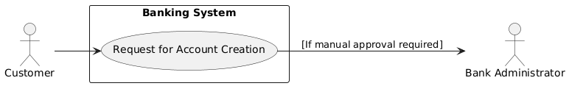

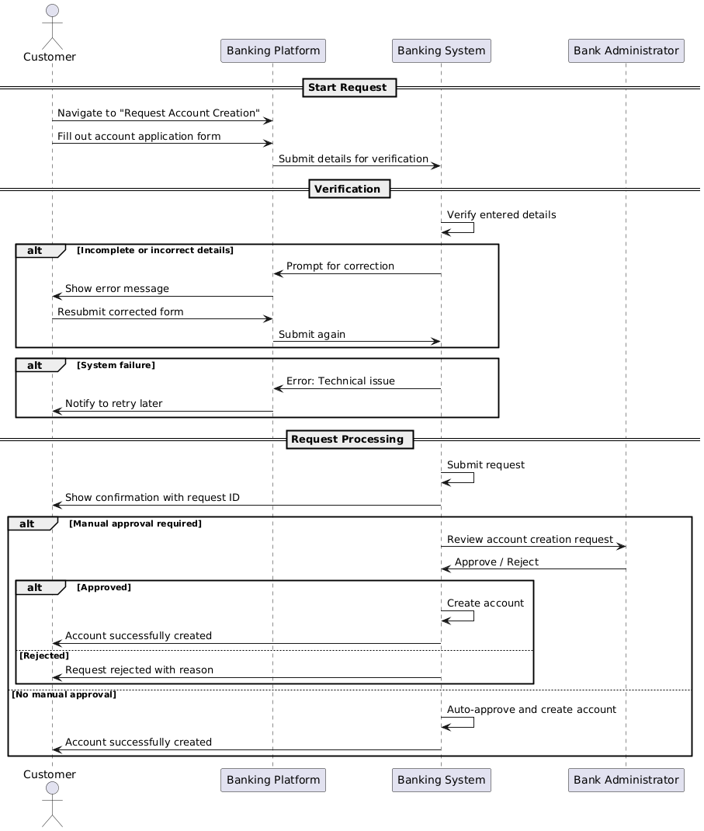

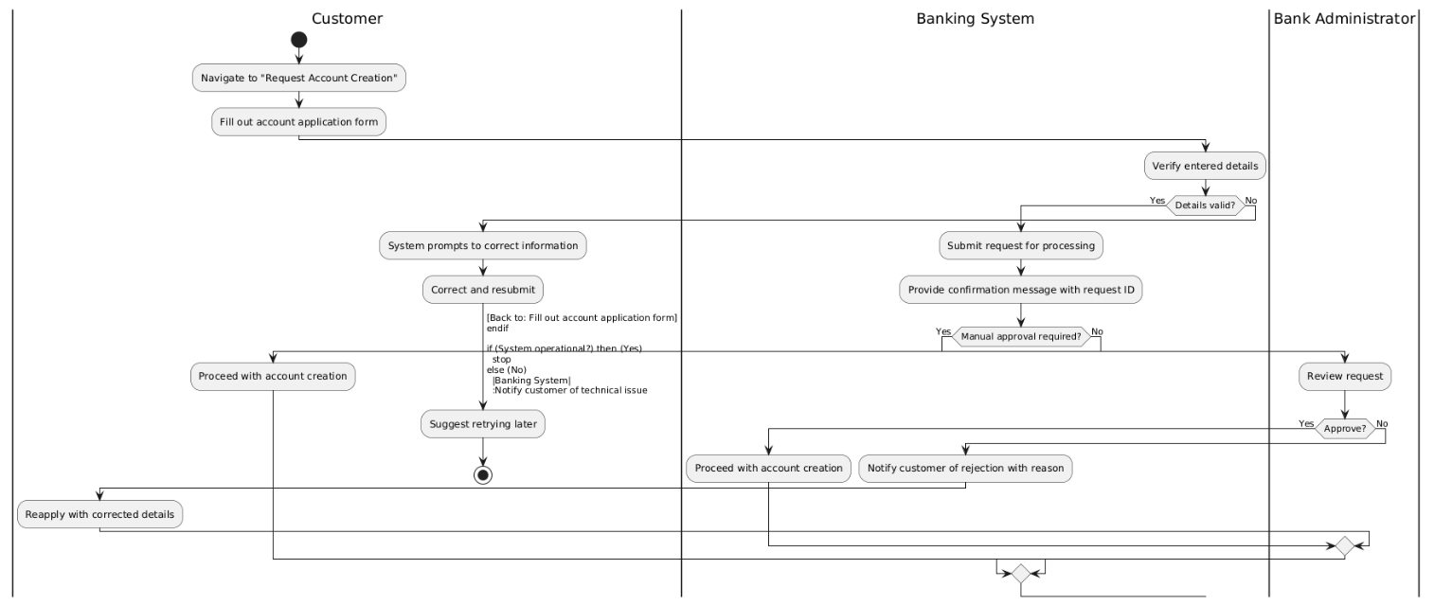

|  |  |
| --- | --- |
| UC Name | *UC_02 Manage Bank Account* |
| Summary | *This use case describes the process by which a customer creates a bank account, views their account balance, transfers money, and receives transaction alerts.* |
| Dependency | *None* |
| Actors | *Customer, Banking System* |
| Preconditions | 1. *The customer must be a registered user of the banking system.* 2. *The customer must provide valid personal information to create an account.* 3. *The customer must have sufficient balance to initiate a transfer.* |
| Description of the Main Sequence | * *Step 1: Customer navigates to the "Create Account" section of the banking system.* * *Step 2: Customer enters required details such as name, address, contact information, and initial deposit amount.* * *Step 3: System validates the entered details.* * *Step 4: System creates a new bank account and generates an account number.* * *Step 5: System displays a confirmation message along with the newly created account details.* * *Step 6: Customer logs in to the banking system.* * *Step 7: Customer navigates to the "Account Balance" section.* * *Step 8: System retrieves and displays the customer’s current account balance.* * *Step 9: Customer navigates to the "Transfer Money" section.* * *Step 10: Customer enters the recipient’s account details and the amount to transfer.* * *Step 11: System verifies the account details and checks for sufficient balance.* * *Step 12: System processes the transaction and transfers the amount.* * *Step 13: System generates a transaction alert and notifies both the sender and recipient.* |
| Description of the Alternative Sequence | *1a. If customer enters invalid details:*   * *System prompts customer to re-enter correct details.* * *Customer re-enters details and submits the request again.*   *2a. If system fails to create an account due to technical issues:*   * *System notifies customer of the failure and suggests retrying later.*   *3a. If customer enters incorrect login credentials:*   * *System displays an error message and prompts for correct credentials.*   *4a. If customer enters an invalid recipient account:*   * *System notifies the customer and prompts for correct details.*   *5a. If customer has insufficient funds:*   * *System alerts the customer and cancels the transfer.* |
| Non functional requirements | * *The system should process account creation within 5 seconds.* * *The account balance retrieval should not exceed 3 seconds.* * *The money transfer should be completed within 10 seconds.* * *The system must encrypt all sensitive customer data.* * *The system should be available 24/7.* * *The system must send transaction alerts in real time.* |
| Postconditions | 1. *A new bank account is created if the request is valid.* 2. *The customer successfully views their account balance.* 3. *Money is transferred to the intended recipient if all validations pass.* 4. *Both the sender and the recipient receive transaction alerts.* 5. *All sensitive data remains secure through encryption.* 6. *System availability and response times meet performance standards.* |

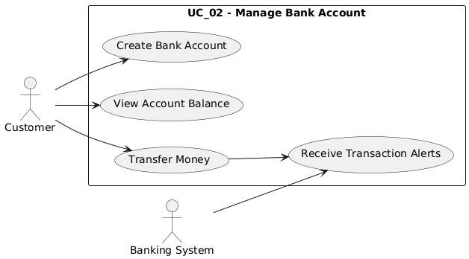

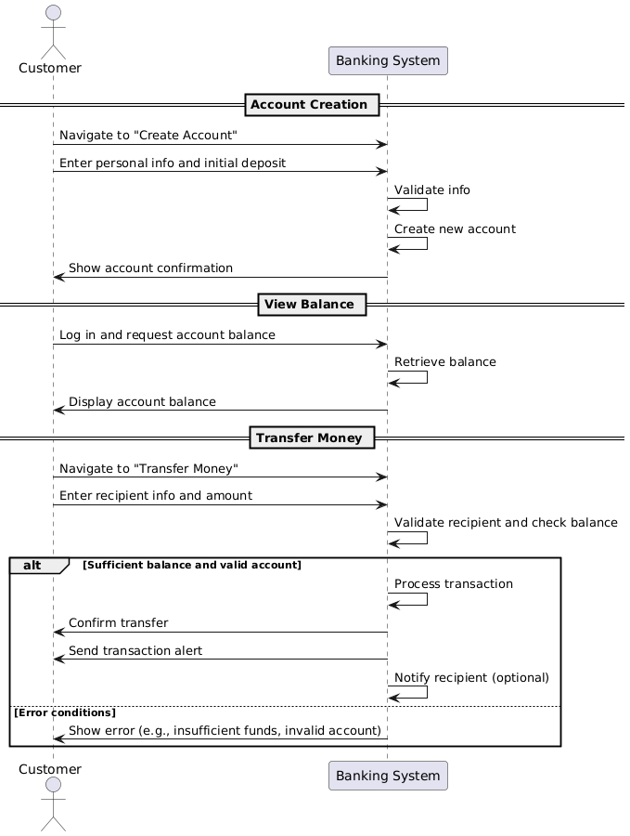

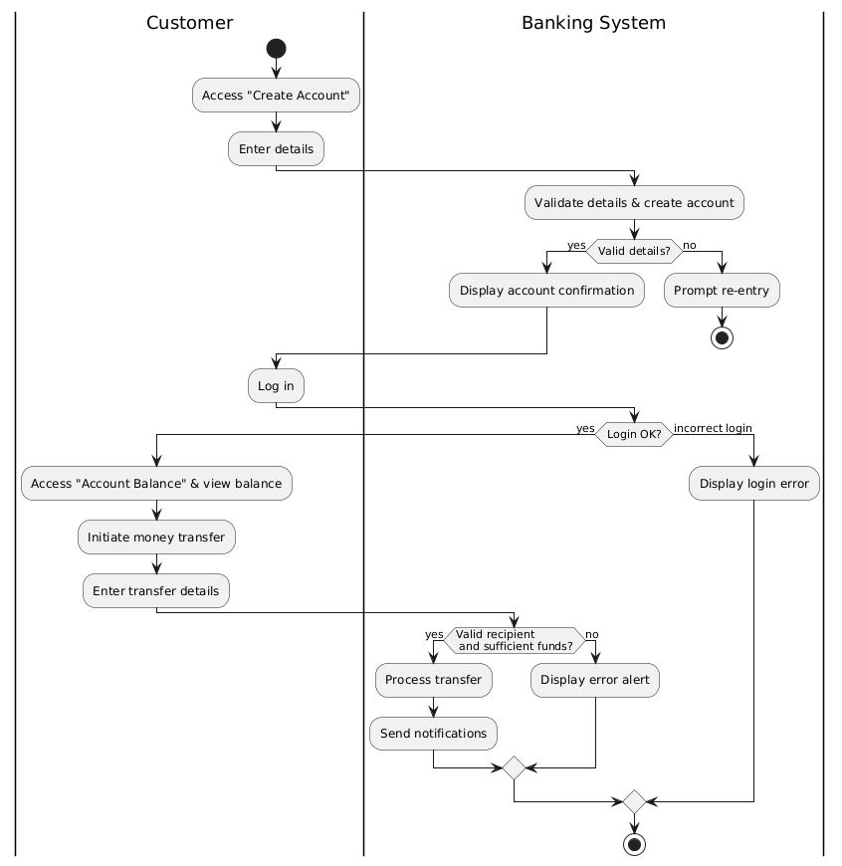

|  |  |
| --- | --- |
| UC Name | *UC_03 Loan Details* |
| Summary | *This use case describes the process by which a customer applies for a loan and views their loan details through the banking system.* |
| Dependency | *None* |
| Actors | *Customer, Banking System* |
| Preconditions | 1. *The customer must be a registered user of the banking system.* 2. *The customer must have a valid bank account.* 3. *The customer must meet the eligibility criteria for loan application (e.g., credit score, income proof).* |
| Description of the Main Sequence | * *Step 1: Customer logs in to the banking system.* * *Step 2: Customer navigates to the "Loan Application" section.* * *Step 3: Customer selects the type of loan and enters required details (e.g., loan amount, duration, purpose).* * *Step 4: System validates the entered details and checks eligibility criteria.* * *Step 5: System processes the application and generates a loan application ID.* * *Step 6: System notifies the customer of the loan application status (approved, pending, or rejected).* * *Step 7: If approved, customer navigates to the "Loan Details" section.* * *Step 8: System retrieves and displays the loan details (e.g., principal amount, interest rate, repayment schedule, outstanding balance).* |
| Description of the Alternative Sequence | ***4a. Invalid Details:***   * *The system prompts the customer to re-enter the correct information.* * *The customer re-enters and resubmits the application.*   ***2a. System Processing Failure:***   * *The system notifies the customer of a technical issue and suggests trying again later.*   ***3a. Loan Application Rejected:***   * *The system displays the reason for rejection.* * *The system suggests alternative options (e.g., applying for a different loan type).*   ***7a. No Active Loan Found:***   * *If the customer tries to access loan details without an active loan, the system notifies them that no active loans exist.* |
| Non functional requirements | * *The system should process loan applications within 10 seconds.* * *The loan details retrieval should not exceed 5 seconds.* * *The system must encrypt all sensitive customer data.* * *The system should be available 24/7.* * *The system must notify the customer via SMS/email regarding loan application status.* |
| Postconditions | * *The loan application is successfully submitted and recorded in the banking system.* * *The customer can view loan details if the application is approved.* * *The system updates the loan status and notifies the customer accordingly.* |

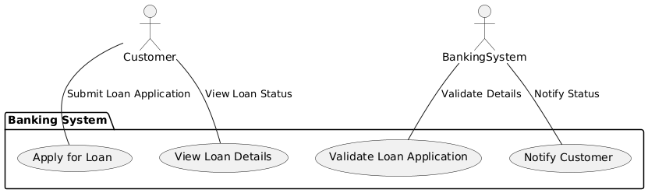

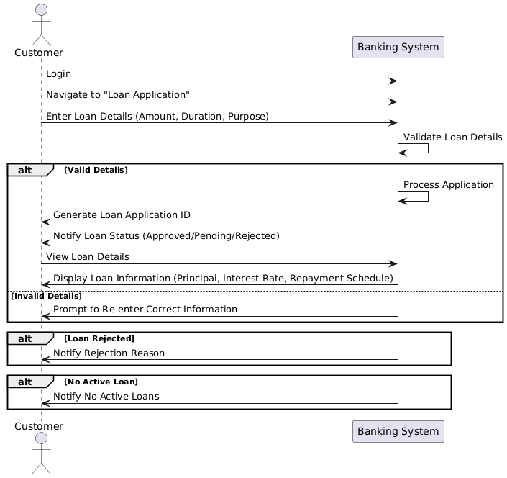

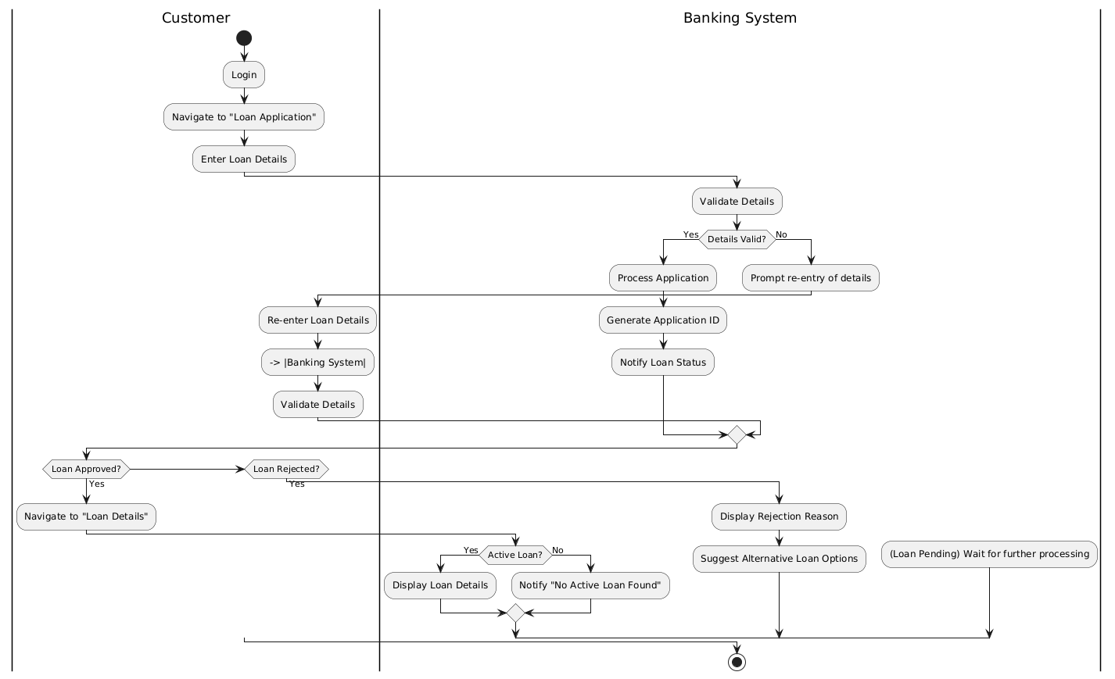

|  |  |
| --- | --- |
| UC Name | *UC_04 Update Security Options* |
| Summary | *This use case describes how a customer can update their security options, specifically changing their PIN.* |
| Dependency | *None* |
| Actors | *Customer, Banking System* |
| Preconditions | 1. *The customer must be a registered user of the banking system.* 2. *The customer must have an active bank account.* |
| Description of the Main Sequence | *Update Security Options (Change PIN):*   1. *The customer logs in to the banking system.* 2. *The customer navigates to the "Security Settings" section.* 3. *The customer selects the "Change PIN" option.* 4. *The customer enters the current PIN and the new PIN.* 5. *The system verifies the current PIN.* 6. *If the current PIN is correct, the system updates the PIN.* 7. *The system sends a confirmation message to the customer regarding the successful change.* |
| Description of the Alternative Sequence | ***Incorrect Current PIN:***   * *If the customer enters an incorrect current PIN while attempting to change the PIN, the system prompts the customer to re-enter the correct PIN.*   ***PIN Update Failure (Security Policies):***   * *If the new PIN does not meet security requirements (e.g., complexity or length), the system notifies the customer and provides guidelines for creating a valid PIN.* |
| Non functional requirements | * + *PIN updates should be completed within* ***3 seconds****.*   + *The system must encrypt sensitive data, including PINs.*   + *Real-time alerts should be sent immediately after a successful PIN change.*   + *The system must be available* ***24/7****.* |
| Postconditions | 1. *The customer's PIN is successfully updated after the change process.* 2. *The customer receives a notification confirming the successful PIN update.* |

